VBS Plan and Roster

Rotation Schedule: Each section ends 5 minutes early to allow for transition time. Parents must come into the sanctuary for dismissal. Grade listed below are grades they will enter in the next school year.

 | 9:30-9:45 | 9:45 | 10:15 | 10:45 | 11:15 | 11:45
Preschool | Sanctuary | PreK Room | Music | Snack & Rec | PreK Room | Sanctuary
K - 1st | Sanctuary | Music | Lesson | Craft | Snack & Rec | Sanctuary
2nd - 3rd | Sanctuary | Snack & Rec | Craft | Lesson | Music | Sanctuary
4th - 6th | Sanctuary | Craft | Snack & Rec | Music | Lesson | Sanctuary

Rotation Locations
- Sanctuary - Opening assembly, music, and dismissal
- Fellowship Hall - Crafts, bad weather option for snack & rec
- Children’s Church Room - Bible lesson
- Shelter House & Field - snack & rec

Age Group Leaders (2 each)
- Nursery: __________________ & ____________________
- Preschool: __________________ & ____________________
- K - 1st grade: __________________ & ____________________
- 2nd - 3rd grade: __________________ & ____________________
- 4th - 6th grade: __________________ & ____________________

Other Potential Helpers (can only help certain days)
- __________________ & ____________________
- __________________ & ____________________
- __________________ & ____________________

Area Specific Leaders (2 each)
- Music - __________________ & ____________________
- Snacks - __________________ & ____________________
- Recreation - __________________ & ____________________
- Crafts - __________________ & ____________________
- Bible Lesson - __________________ & ____________________
- Offering & Attendance Count - __________________ & ____________________
- Registration Table - __________________ & ____________________

Explanation & Tips

This simple one-page documents is the heart of my VBS planning process. No matter what theme changed, I kept the basic format and usually the same helpers in their favorite places from year-to-year.
My typical VBS using this plan was between 75 – 125 children per day.

My goal was to make things hassle-free for the volunteers so they could focus on their ministry roles. This mean zero required group meetings. I would onboard new leaders personally and let the veterans take 100% ownership of their own areas.

This finished document was posted everywhere in the church, emailed to confirmed volunteers, and printed for their clipboards each morning.

Room Use: We kept things simple. The only group that had a home-room was preschool.

Decorating Team: Anyone available could be on the decorating team. We usually got the props together in my office then worked as a team all week leading up to VBS. That mean the sanctuary was in full VBS mode for the church service too!

Recruiting: I would personally reach out to last year’s volunteer roster and confirm their role for the coming VBS program. This paper was my recruitment rosters – I just kept it open on my PC and did the work. To confirm volunteers I always got their t-shirt size. This was a simple phone call or text message.

The key positions were always the Rotations Leaders. These volunteers would get the curriculum materials as soon as they were confirmed. I would let them know how much budget I had to reimburse their expenses (i.e. for crafts or snacks). It was their role to go buy the supplies and get everything ready.

Find the right people and empower them to do the work – them support them as needed but trust their choices. As the director it’s your job to handle the big picture and let the volunteers do their job.

Other potential leaders were my list of people I wanted to recruit, even if they could only work one day. The idea was to get as many people as possible involved. Maybe a dad could work one shift of recreation on short notice. Maybe a grandma could lend a hand in the kitchen one morning. The rotation leaders were ready to include any extra help – even if they didn’t depend on it.

My recruiting mindset was always this – all church members & parents were part of the VBS team by default. It was my job as director to find the best place (or way) for them to serve.

Age specific leaders had no responsibilities except to show up on time, follow my directions, and be ready to show love to the kids. Often, I would give them directions in the opening assembly – i.e. make sure you learn everyone’s name today. During the day I would rotate through and offer support as needed.
We hope you enjoy this free resource.
Everything from Ministry-To-Chidren.com is 100% free to copy & use in ministry.

I’m Tony Kummer - I started this website in 2007, but God is using it beyond my imagination. The mission is simple.
Help you tell kids about Jesus!
Our team is honored that you choose our material. Thank you for …
- serving where God has placed you.
- telling children about Jesus.
- allowing us to be a part of your mission.

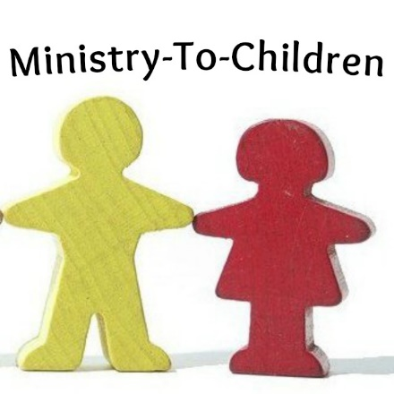
We don’t ask for money, but we do need your help.
Please consider the following:
- Comment on the website to encourage our authors.
- Link to us from your blog or church website.
- Share our posts on Pinterest or Facebook.
- Tell a friend to google “Ministry to Children.”
- Add me (and our team) to your personal prayer list.

I’d love to hear your feedback on this download. Tony@ministry-to-children.com
May God bless you and continue to bless your ministry!

