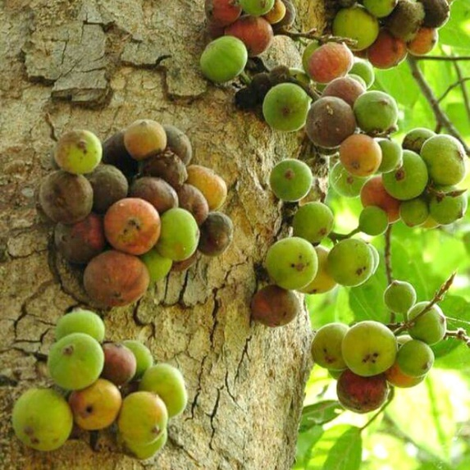
Living a Fruitful Life (Luke 13:1-9) Children’s Message
Written by Kristen Schmidt for Ministry-To-Children.com
Law and Gospel; Fruit Bearing Life
Main Objective: There are some tricky points for kids in this Gospel lesson. Everyone is going to die? If we don’t have figs, we are going to be plucked out and cast aside? What do these things mean? In this message, children consider the principles of grace in light of opposites. God’s love allows us to receive the opposite of what we deserve for the things we’ve done. When we abide in God’s presence and live through Christ, our otherwise dead lives will be fruitful, meaning good things will come from them.
Law/Gospel Theme: Every single person has sinned and deserves punishment. Because God loves us and sent Jesus to us, we do not have to suffer. As a result, we should stay rooted in God. When we do, our lives will reflect Christ’s love and positive things will come out of them.
Optional Object Lesson Materials : Dying plant or branch, healthy plant, fruit; fruit-shaped stickers or small toys

Children’s Message (Luke 13:1-9) Living a Fruitful Life
Note: All elements are open to adjustment. Cater to the needs and ages of your group
Come to deliver the message and greet children
“Hello! We are going to start today with a little opposite game. Do you know what opposite means? (allow responses) Well, can you help me come up with some opposites?
What is the opposite of young? (old) How about hot? (cold!) What’s the opposite of short? (tall) Big? (small!) What is the opposite of happy? (sad) What’s the opposite of good? (bad) What’s the opposite of a reward? (A punishment) What is the opposite of dead? (Alive)
Now, today our Gospel lesson sort of talks about some things that are opposites, and it has to do with how our lives are with and without God. I want to show you something (hold up dead plant): does this plant look healthy to you? Not really. I think if this was planted in my yard, I would probably want to throw it away and try again…but if it was doing what it was supposed to do, it would have pretty flowers or fruit on it.
Do you like fruit? I love fruit. When fruit trees are planted in good soil and have water and sunshine, they give us tasty things to eat and enjoy. Well, the Bible tells us that when we are rooted in God’s love, when we pray and read our Bibles and trust the Lord, our lives will have good things come out of them. But if we walk away and don’t trust in Jesus, we will dry up like this shriveled plant. See, the first part of today’s reading says that everyone has done bad things and that bad things earn punishment. We all sin, and we are supposed to perish because of that (perish means we are supposed to die!).
Well, the great news is that because Jesus died, we get the opposite of what we deserve. We deserve punishment and death, but we get grace and life! God promises that when we accept His love and grace, and say we are sorry for the bad things we have done, He will give us new life. And that includes producing fruit! What kind of fruit do our lives produce? (hold up orange/apple/banana)
Not quite this kind of fruit… our fruit looks like things that Jesus would demonstrate: love, kindness, patience, joy, gentleness, self-control…that means we care about other people, and we want good things for their lives too. Sometimes that might be the opposite of what we feel like doing. But if we are truly connected to Christ, these fruits grow naturally, and they help others. That is truly great news!”
Optional take home: give each child a fruit shaped eraser, trinket, stickers, or even a small piece of fruit to take away, to remember that our lives bear fruit when they are close to God.
Prayer: Offer thanks that God will be with us no matter where we go:
(Have kids repeat each line, if desired)
Dear God,
Thank you for your grace
Thank you for forgiving our sins
Please help us grow in you
So that we can bear fruit
Thank you for your love, Lord
We love you!
In Jesus name we pray, Amen

Bible References (or for additional exploration):
Luke 13:1-9 NIV
There were some present at that very time who told him about the Galileans whose blood Pilate had mingled with their sacrifices. 2 And he answered them, “Do you think that these Galileans were worse sinners than all the other Galileans, because they suffered in this way? 3 No, I tell you; but unless you repent, you will all likewise perish. 4 Or those eighteen on whom the tower in Siloam fell and killed them: do you think that they were worse offenders than all the others who lived in Jerusalem? 5 No, I tell you; but unless you repent, you will all likewise perish.”
6 And he told this parable: “A man had a fig tree planted in his vineyard, and he came seeking fruit on it and found none. 7 And he said to the vinedresser, ‘Look, for three years now I have come seeking fruit on this fig tree, and I find none. Cut it down. Why should it use up the ground?’8 And he answered him, ‘Sir, let it alone this year also, until I dig around it and put on manure. 9 Then if it should bear fruit next year, well and good; but if not, you can cut it down.’” -Luke 13:1-9
Galatians 5:22-24 NIV
But the fruit of the Spirit is love, joy, peace, patience, kindness, goodness, faithfulness, 23 gentleness, self-control; against such things there is no law. 24 And those who belong to Christ Jesus have crucified the flesh with its passions and desires. -Galatians 5:22-24
Fig Tree Image Credit: Naveedanjumkhan. Fig tree, from Art in the Christian Tradition, a project of the Vanderbilt Divinity Library, Nashville, TN. http://diglib.library.vanderbilt.edu/act-imagelink.pl?RC=56836 [retrieved March 18, 2019

