[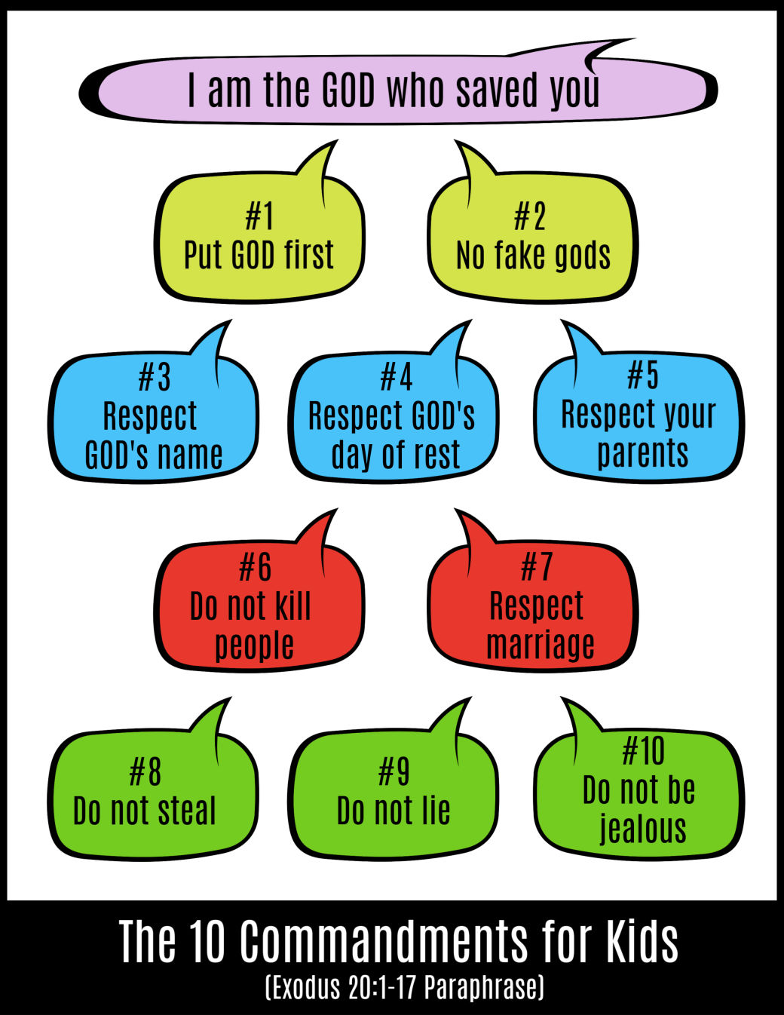](https://ministry-to-children.com/ten-commandments-lesson-for-kids/)