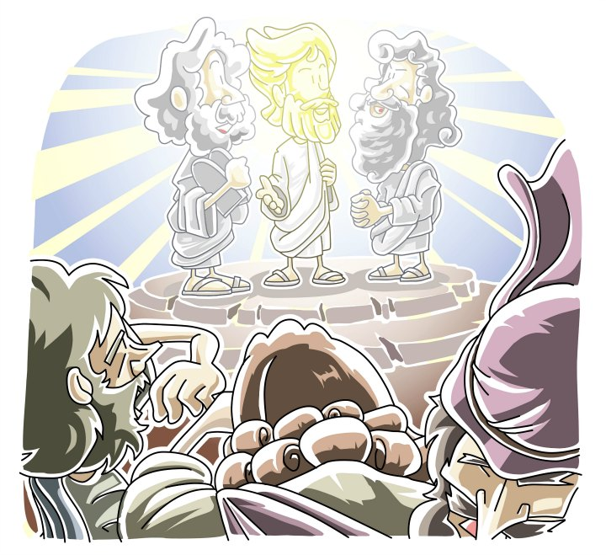
Children’s Sermon on the Transfiguration of Jesus
- Items needed: Prescription eye glasses
- Scripture Passage: Luke 9:28-36 also in Matt. 17:1-13; Mark 9:2-13
- Directions in italics – lesson in regular font.
- You can teach directly from this text, but your sermon will be more effective if done from memory but in your own words.
- Audio example on Ministry-To-Children.com

Greet the children as they sit down around you, saying how you are happy they have come…
Hold up your pair of prescription eye glasses
Can anyone tell me what these are? Allow for responses …
Can anyone tell me why I need to wear them? Allow for responses …
That’s right – I need to wear these to see things how they really are – my eyes aren’t perfect, but these change the way I can see things so I can know what is real.
In our Bible reading today we heard about the Transfiguration of Jesus. Transfiguration is a big word that means change – Jesus change the way the disciples could see him so they would know what was real.
One time, Jesus went up a tall mountain with some of his disciples to pray.
It was late at night, so everyone was getting very sleepy. Can you show me your sleepy faces? Allow a moment for the kids to demonstrate a sleepy face …
Good job - that’s how the disciples looked, but then something happened that made them wide awake. Can you show me your wide-awake faces? Allow a moment for the kids to demonstrate a wide-awake faces …
Exactly right – something very surprising happened. They saw a change come over Jesus and his clothes became shinny white. It was different than anything they had ever seen!
But then something else happened. Can you make show me those surprised faces again? Allow a moment for the kids to demonstrate a surprised faces …
They saw two men from the Bible, Moses & Elijah, who had gone to heaven a very long time before. They showed up and started talking to Jesus about what the special work Jesus was going to do when he got to Jerusalem.
Just then a cloud came down and covered everyone and the disciples became afraid. Can you show me your afraid faces? Allow a moment for the kids to demonstrate afraid faces …
Good job – that’s exactly how the disciples felt. Something amazing was happening and they were very confused until they heard a voice from the cloud say, “THIS IS MY SON, LISTEN TO HIM.”
Can anyone tell me who’s voice that was? Allow a moment for responses …
That’s right – it was the voice of God making sure they understood that Jesus was his son. Then the cloud disappeared and only Jesus was there. After that, they always looked at Jesus a little different because they saw how things really were.
This story is like my glasses (point back to your eyeglasses). They help me see what’s real and Transfiguration showed the disciples what was real about Jesus. It shows us what is real about Jesus.
Jesus is God’s one and only Son. He looked like a normal person, but he was really someone very special. God wants us to listen very carefully to all the words of Jesus in the Bible.
Let’s pray together, you can copy after me. After each line in the prayer, allow a moment for the children to repeat.
Dear God,
Thank you for Jesus.
That he loves us.
And came to save us.
Help us to listen to Jesus
And see what is real.
In Jesus name we pray,
AMEN.

